JPQL : Java Persistence Query Language

SQL

Select \* from product; product is table name and not a case sensitive. this query retrieve all records from a table.

Select \* from product where pid=100;

Select \* from product where price > 50000

Select pid from product;

Select pname from product

Select pname,price from product

JPQL or HQL

select p from Product p; Product is entity class name or java bean class name. case sensitive an p is object. using p we are retrieving all variable values.

select p from Product p where p.pid=100; here p is object and pid is variable name.

retrieving partial object

select p.pid from Product p;

select p.pname from Product p;

select p.pname,p.price from Product p

spring framework with ORM : Hibernate or JPA.

Spring framework using annotation / xml we can use

1. Jdbc
2. Hibernate
3. Jpa

Spring boot with Rest API with JPA

<https://start.spring.io/>

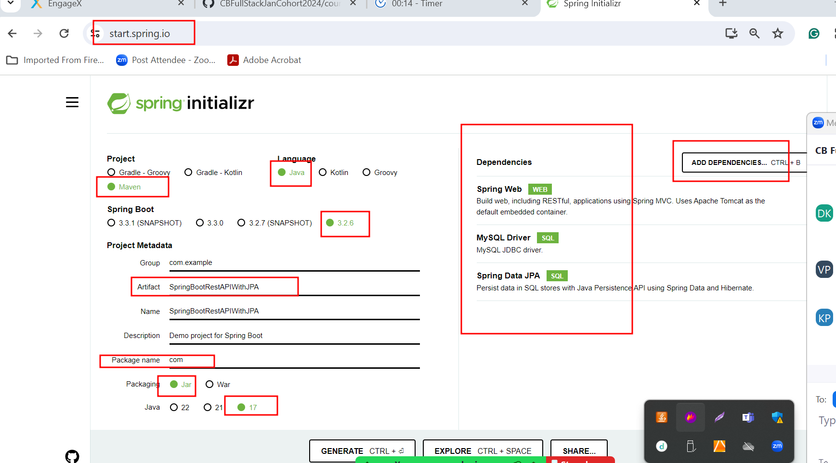

In spring boot

application.properties or application.yml

this file contains all configuration details depending upon project requirement.